Requirements/Design Specification

**Capture Branding**

Revision History

|  |  |  |  |
| --- | --- | --- | --- |
| **Date** | **Revision** | **Description** | **Author** |
| 2/10/2015 | 1.0 | Initial Version with Requirements | Roger |
| 2/18/2015 | 1.1 | Updated requirements based on branding meeting | Roger |
|  |  |  |  |
|  |  |  |  |
|  |  |  |  |

The information furnished herein by Republic Services Inc. is proprietary and confidential to Republic Services Inc. personnel and is not to be duplicated, published, or disclosed to any third party in whole or in part without permission from Republic Services, Inc.

© Copyright 2012, Republic Services Inc. - All rights reserved.

Table of contents

1 Business Requirements 6

1.1 Purpose of the Design Specification 6

1.1.1 Business Functional Requirements / Configuration 6

1.1.2 Technical Design Requirements 8

2 Assumptions 9

3 Technical Design 9

3.1 Referenced Documents 9

3.2 Process Flow and Mock Ups 9

3.3 Functional Logic 10

3.4 Data Sources & Mapping 10

3.5 InfoPro Interface 10

3.6 BI Interface 11

4 Report Changes 11

5 Appendix 11

# Business Requirements

## Purpose of the Design Specification

This document highlights items to be updated froma marketing and branding perspective.

### Business Functional Requirements / Configuration

| **Business Functional Requirement** | **Notes** |
| --- | --- |
| 1. Update blue header within Capture | All headers should be blue   * RGB - 0/74/124 * HEX - #004A7C |
| All republic images need to be replaced with the following: | * Top right column of every page on application * Top right of CSAs (both customer & office use) * Top left of Sample Invoice (both pages) |
| 1. Replace the LOB Images on the Select Service Offering page | * Small Container, Large Container and Additiona Items will be replaced. See section 3.2 |
| 1. Buttons | All buttons should be blue   * Hex #004A7C * RGB 0/74/124 |
| 1. My Resource collateral | Add a checkbox for my resource collateral on Gen Docs page. |
| 1. Proposal Cover Letters | There will be unique cover letters for New and Existing for each PBS business segment and divisions that do not sell recycle; totaling 8 cover letters. Cover_Letters.zip contains the 8 cover letters needed to be created within Capture. Logic for implementing can be found in TDR-001. The bottom image on the document is broken out into individual images. Use the .png within the RS_BLUELINES_LOCKUP_RGB.zip below for the image. *Also, change the My Resource refrence links from Republicservices.com link to RepublicOnline.com. |
| 1. Proposal Changes | * Get rid of top blue bar * Use white background logo. Enlarge to cover top of old blue bar and bottom of current immage * Proposal verbiage = light blue |
| 1. Marketing attachment for MSW changes | Replace containers on select service screen MSW PDFs (small and large). See section 3.2 Figure 2. Get rid of old ones. |
| 1. Once development work is almost completed take duplicate screen shots of new colors and images and sent to branding team. | Brett Beitzel  Mike Cross |

### Technical Design Requirements

| **Technical Design Requirement** | **Notes** |
| --- | --- |
| 1. Generate Docs   Assigning the correct cover letter | One of 8 new cover letters will be used as an option to be printed with the proposal. See section 3.2, Cover_Letters.zip for the actual file. Below is pseudo code  If existing customer then check segment  If Division can not sell recycle then “Proposal Letter Existing Customer Generic No Recycling”  ElsIf Price then “Proposal Letter Existing Customer Price”  ElsIf Performance then “Proposal Letter Existing Customer Perform…”  ElsIf Enviornmental then “Proposal Letter Existing Customer Environmental…”  Else ERROR  ElsIF Any New Customer then check segment  If Division can not sell recycle then “Proposal Letter NEW Customer Generic No Recycling”  ElsIf Price then “Proposal Letter NEW Customer Price”  ElsIf Performance then “Proposal Letter NEW Customer Perform…”  ElsIf Enviornmental then “Proposal Letter NEW Customer Environmental…”  Else ERROR  FI |
| Commerce | For developer, perhaps new variable? |
| Config | For developer, perhaps new variable? |
| Documentation   * CSA * Proposal * Sample Invoice | Update images based on functional specs and section 3.2  Create new documents for cover letters |
| InfoPro Interface | None |

# Assumptions

The following items are out of scope

None

# Technical Design

## Referenced Documents

republic_brandguide_v1.pdf

## Process Flow and Mock Ups

Leave image as is

Figure 1

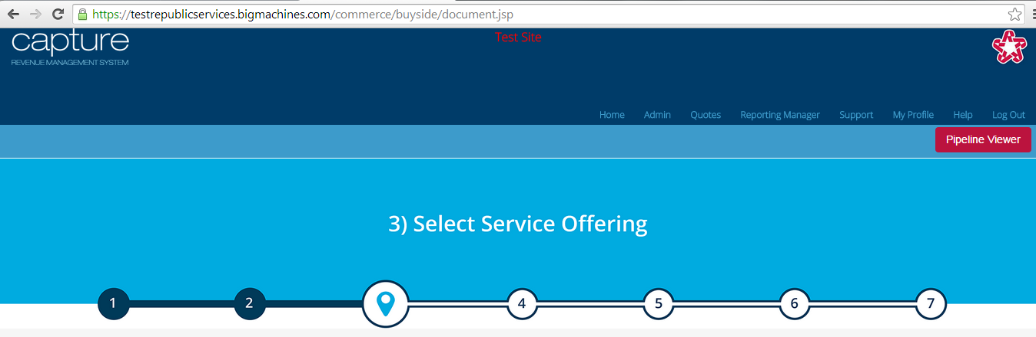

Header BFR 01

RGB - 0/74/124

HEX - 004A7C

Figure 2

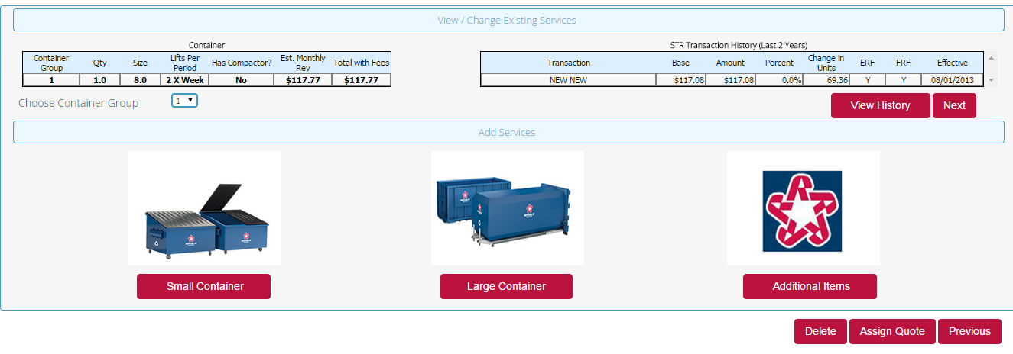

Replace with images in BFR-008

CSA logo remains the same. No CSA changes

Figure 3

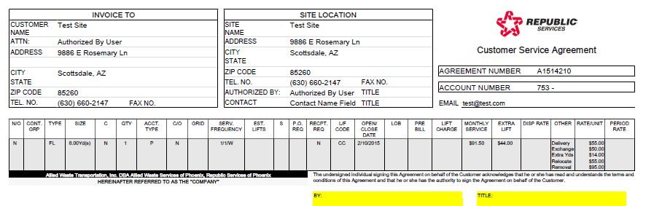

## Functional Logic

NA

## Data Sources & Mapping

No data changes made

## InfoPro Interface

Should not affect the AAE process. All data is currently available. There could potentially be a new field to identify which cover letter to use.

## BI Interface

Should not affect the BI process. All data is currently available. No fields should be repurposed.

# Report Changes

No Changes

# Appendix